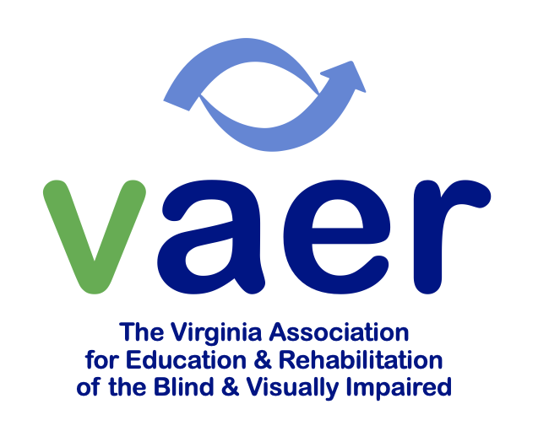
BARBARA MCCARTHY SCHOLARSHIP
2025 - 2026 Information

Virginia AER awards scholarships annually to undergraduate or graduate students with exemplary academic achievements and a strong commitment to serve people with visual impairments. This scholarship is named in honor of Barbara McCarthy for her dedication, passion, commitment, and leadership within the field of education for persons with visual impairment. The annual scholarship award is $1500 along with an AER Student membership and upcoming state conference registration in March of 2026.

Eligibility Requirements:
- Must be a resident of Virginia enrolled in a professional preparation program in the field of vision or a non-resident of Virginia enrolled in a Virginia preparation program.
- Must be an undergraduate or graduate student with the intent to pursue licensure in the Vision field.
Deadline: Submit the following documents, electronically or in hard copies, by January 5, 2026:
- Resume
- Two (2) letters of recommendation from professionals
- A copy of a current non-official transcript(s)
- Completed Virginia AER student scholarship application
- A written essay contributing to the following prompt:
What inspired you to pursue a career supporting individuals who are blind or visually impaired, and how has that motivation shaped your professional journey?
- Optional: AER membership number and expiration date

Please contact Sarah Franz (sfranz@ais-llc.com) with any questions or concerns.

BARBARA MCCARTHY SCHOLARSHIP
2025 - 2026 Application

1. Name of Applicant:

2. Current Mailing Address:
Telephone:
E-mail:

3. Name and Address of Someone who will always know where and how to reach you now and after graduation:
Relationship to You:
Telephone:
E-mail:

4. Academic Program:
Name of college/university and academic program:

Supervisor/Director/Coordinator of Academic Program in Visual Impairment:
Name:
Address:
Telephone:
E-mail:

5. About Your Progress:
Your current year or status:

Are you a full-time or part-time student?

When do you plan to graduate?

What are your current credit hours?

What is your current major?

What is your grade point average to date?
6. Have you applied for this scholarship before? Yes/ No
(You may resubmit an earlier application with updates as needed)

7. Briefly state why you are applying for this scholarship.

8. Describe your career goals, related experiences, and your plan to participate in/ contribute to the lives of people with vision impairments for the coming years.

Submit the completed application with packet by January 5, 2026 by email or mail:

sfranzais-llc.com

or

Sarah Franz
2025-2026 VA-AER Scholarship Selection
8865 Seaycroft Dr.
Mechanicsville Virginia 23116

